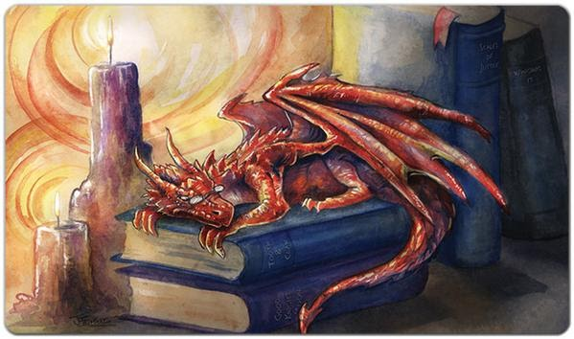
Library Board Meeting
February 17, 2021 5:00 pm

- Call to Order
  - Minutes of the previous meeting
  - Financial Report
  - Director’s update
- Business
  - Annual Report
  - Statement of Effectiveness regarding WVLS
  - Fundraising - calendar project
  - Re-opening plan
III. Closing
- Concerns and Comments
- Next meeting date
- Adjournment

